WMWT5NAJAWA

In The Name of Allah The Most Merciful, The Most Kind
This session is based on verses 7 to 11 from Sura Mujadila.
58:7
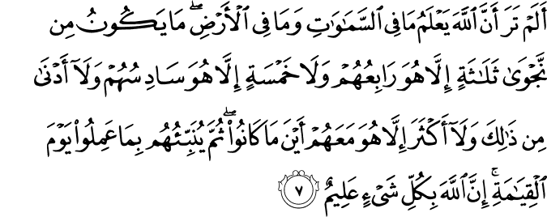
Have you not considered that Allah knows what is in the heavens and what is on the earth? There is in no private conversation three but that He is the fourth of them, nor are there five but that He is the sixth of them - and no less than that and no more except that He is with them [in knowledge] wherever they are. Then He will inform them of what they did, on the Day of Resurrection. Indeed Allah is, of all things, Knowing.
58:8
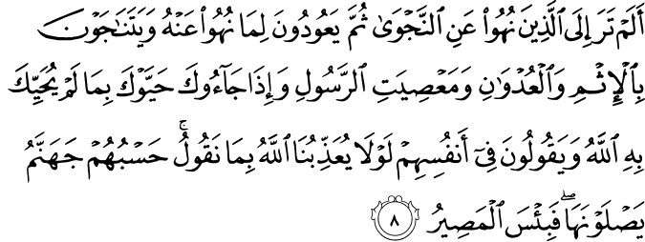
Have you not considered those who were forbidden from private conversation, then they return to that which they were forbidden and converse among themselves about sin and aggression and disobedience to the Messenger (s)? And when they come to you, they greet you with that [word] by which Allah does not greet you and say among themselves, "Why does Allah not punish us for what we say?" Sufficient for them is Hell, which they will [enter to] burn, and wretched is the destination.
58:9
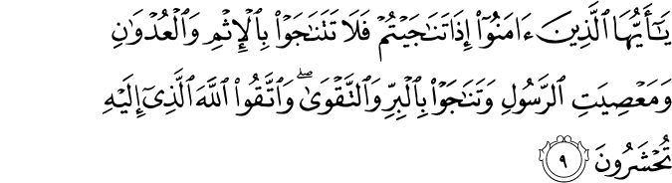
O you who have believed, when you converse privately, do not converse about sin and aggression and disobedience to the Messenger (s) but converse about righteousness and piety. And fear Allah , to whom you will be gathered.
58:10
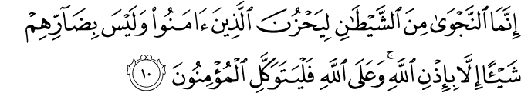
Private conversation is only from Satan that he may grieve those who have believed, but he will not harm them at all except by permission of Allah . And upon Allah let the believers rely.
58:11
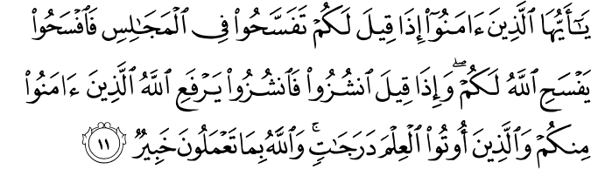

O you who have believed, when you are told, "Space yourselves" in assemblies, then make space; Allah will make space for you. And when you are told, "Arise," then arise; Allah will raise those who have believed among you and those who were given knowledge, by degrees. And Allah is Acquainted with what you do.

Najwa
This session is about something which destroys Islamic work and that is Najwa. Najwa is mentioned a couple of times in this passage from Sura Mujadila. Before we start the discussion let’s talk about the essence of najwa. Najwa means secret discussions with malicious intentions. How does Najwa develop?
Sub-Groups
Essentially in any organization there is a tendency for sub-groups to develop. Let us suppose there are six people in a committee and three of them are very close friends. So the six meet every week but three of them have dinner afterwards because they are close friends. And during the dinner they discuss the same things that were discussed in the meeting and share more opinions about it. What happens then is that you have a sub-group forming within the main group because they discuss a lot more with each and their opinion becomes solid so when they come to the meeting they already have a single opinion and they are very defensive about that. And anything that comes up against their way or opinion, they deflect it. So they have becomes like a lobby. What this does is that it disperses the unity and frankness of the gathering and of the decision-making and it cuts away at shura (mutual consultation) because in shura everybody has an equal access to give an opinion and everybody shares their opinion on the same platform. They do not meet afterwards and form blocs on the outside. This forming of a bloc on the outside is najwa. The linguistic meaning of najwa is to get away from or escape from the main body and become an independent entity. So a private meeting for malicious or evil purposes is what najwa is.
Evil Assemblies
Surah Al-fath talks about najwa that is catastrophic. That can destroy Islamic work. It can destroy the Islamic school, the masjid, or any organization. Because a few people discuss things which they should not discuss so they are breaking a trust because such meetings and what is discussed in them are a form of trust. So najwa violates that trust. For example there’s a masjid and they are discussing whether or not they should build a gym so they have a meeting. So everyone on the board is giving an opinion and there are discussions going on. But when the meeting is over, four people on the board get together at one of the guy’s houses and they start discussing about what went on in the meeting and say things like, ‘Why are they spending so much money on a gym? Who comes any way? What about the insurance? What about this? What about that?’ They said none of those things when they were in the meeting. That was the place to say it. The fact that you have an opinion or a concern means it should be said at the meeting and that is shura. If you don’t open your mouth then you shouldn’t open your mouth anywhere else. Then you come in the next meeting all angry because if one person is upset and they talk to another person the anger is not doubled, it’s squared. It is exponentially worse. Another example is lets us suppose two people are talking about a khutbah and one says, ‘You know the khateeb said something I really do not understand or I wasn’t comfortable with what he said.’ Up until then it was just a minor thing but if four people start discussing it, by the end of it the khateeb is a Kafir. It was a small problem, but when four or five people discuss a small problem it becomes a big problem. It becomes a huge deal and this is essentially what najwa does. It allows for small issues that can be dealt with very easily and turns them into very big issues Shura is not who you discuss with but when you discus. There’s a time and a place to give your opinion.
Now in the Prophet (s) case there were a few classes of people in the gathering. Most were Muslims, there were also weak Muslims and hypocrites were there too. The latter didn’t open their mouths when the Prophet (s) was talking. When he was done then they gathered with others and started their, evil talk. 'Hey, what did he just say? What’s he talking about?’ So right after the meeting they started undermining what the Messenger (s) just said in the meeting. Right after the halaqa. This is najwa . This is destructive to Islamic work . This is something you should not be a part of. If you are the guy that’s starting it, stop it. And if you are the guy innocently standing there listening, stop listening and walk away. Don’t hang around, don’t be a part of it.
Let’s now discuss these verses.
‘Have you not considered that Allah knows what is in the heavens and what is on the earth? There is in no private conversation three but that He is the fourth of them, nor are there five but that He is the sixth of them - and no less than that and no more except that He is with them [in knowledge] wherever they are. Then He will inform them of what they did, on the Day of Resurrection. Indeed Allah is, of all things, Knowing. Have you not considered those who were forbidden from private conversation, then they return to that which they were forbidden and converse among themselves about sin and aggression and disobedience to the Messenger?’(58:7-8)

Good Najwa?
A few years before the above verses it was revealed in Surah Nisa:114, “There’s no good in the Najwa that they do.’ Meaning that most of the time when they have a secret meeting, no good comes out of it unless the intention of the secret meeting was to take the good work further, to give charity, to make reconciliation between the people or some other good. Remember this is the exception not the general rule. So if you are doing najwa don't assume its good najwa. Its probably not, but here’s an example of a good najwa. The masjid committee decides that, ‘We should build a gym at this Masjid. We should have a fundraiser next month.’ It’s all agreed upon. Then three of you get together over ice cream and you decide, ‘Hey before the fundraise stands let us put 5000 each and let’s just get it rolling, just the three of us for the sake of Allah. Let’s just do it ahead of everybody else.’ Or after a meeting you noticed one guy was particularly angry and a few of you get together and you decide to speak to this brother. ‘Brother we love you, we are in this together.’’ He says, ‘No, but they do not listen to me or my opinion, I keep telling them but they never listen, why should I be in the Shura? Why did they make me a member if they don’t listen to me?’ ‘Bro, look, we love you. We value your opinion and more than that Allah values your opinion and Allah knows you are sincere. We want you to come. We don’t want you to be angry. Anger is from the shaytan.’ He replies, ‘Yeah, ‘I guess you are right.’ That’s good najwa. The decision was already made. You didn’t go and undermine that decision, you propelled that decision further, and you gave it more momentum. That’s good Najwa that’s putting out fires, not starting them. So you should refrain from najwa and if you do it, it better be good and if it has the potential of turning into a bad thing, stay away from it. Don’t go near it no matter. So many verses of the Quran are dedicated to this thing so it can’t be a small matter. Allah did not mention it just once, but repeatedly. ”
Forming Blocs
The next part of the verse says, ‘They keep holding secret gatherings that add to sin and animosity.’ This is because when you have najwa the grip of your bloc becomes tighter and you develop a nature animosity towards the other members. This is what happens in most masjid elections across the country, najwa, najwa, najwa, and it’s so sad. And then we wonder why there is no baraka in our masajids. You walk into a masjid and you feel, it’s not a real masjid. Alternatively when you walk into a blessed masjid you also know it, you will feel it. When you walk into a masjid that is bankrupt from baraka you will feel nothing, it’ll be just a building. The goodness is sucked out of it. najwa is one of those things that suck the goodness out of a masjid. It just plucks it out of the masjid and this unfortunately has become the scene of many Islamic organizations that are undercutting one another. Dirty politics and murky elections etc. Why are they holding secret meetings and asking people to vote for them? What are they doing? We are in this work for Allah . That’s it. There should be no other aim. If we are not given the opportunity to serve in one organization, it does not mean that we can’t serve in other organizations or projects. Don’t let us get hung up on our titles like, president of the masjid, chairman of the board of directors etc. Once we start going after titles we start becoming proud and think all good things come from us and if it’s not from us, it can’t be good. What will we get out of titles and positions? There’s a better title, Abd Allah. It’s available and we can take it. We don’t have to be this or that, we don’t have to vie for it. Everybody can have it. I go to masjids across the country and in every masjid I come across 2-3 people who say, ‘I started this Masjid all by myself Alhamdulillah. All praise belongs to Allah but nobody was here when I started this masjid.’ Yes, except the other two who also started this masjid by themselves.
Undermining The Leader
Now in these ayat we have to understand that the role of the Messenger (s) was not just as a Messenger (s) but as an head of an organization and some of his followers, were now going to undermine his position as the head.
The guidance we are getting in these verses is that when these people get together they start demoralizing him and when they get to the meeting, they mock him so he looks bad. ‘Then they greet you with what Allah did not greet you with.’ Allah greets the Messenger (s) with salaam . But they say, As’ saam alaikum,’ which means, ‘Death be upon you.’ The other meaning is that they say Salaam but they don’t mean Salaam. It’s like answering the greeting in such a way that you give a look of death. That’s not salaam and that’s not peace. Insincere greetings and when they curse the Prophet(s) and see that, no punishment came upon them, no lightening struck them. They say ‘How come Allah did not punish us for what we say?’ If he really was a Messenger (s), we would have been obliterated the moment we insulted him. What kind of a Messenger is this?.’
You see it started with najwa and it ended up with them losing their imaan. In that meeting deep down inside they said words of Kufr. ‘The only thing enough for them is hell and what a horrible place that is.’
‘Those of who you who have imaan when you are alone in a secret meeting then do not hold a meeting full of sin and animosity and disobedience to the messenger instead have a meeting that leads to goodness and taqwa. Be mindful of Allah, for you will be herded towards him. Verily najwa is from Shaytan.’
That entire secret assembly, that entire secret meeting, that sub-meeting in the car parking lot, that’s from Shaytan. It’s only there to cause grief. You see the twelve people held a meeting and everybody agreed. Everybody made dua afterwards. The meeting is done. As you are leaving you notice the three trouble makers are standing in the parking lot in the corner and talking and pointing fingers and you think, ‘I can sense trouble there.’
So they can cause grief. But others shouldn’t be too worried. They are not going to be harming them at all except by the permission of Allah. Just like in shura we put our trust in Allah. Just like in the problem of najwa we put our trust in Allah . Now one of my favorite parts of the ayat about problem solving.
Troublemakers
When people come as a block what immediately comes to mind? Troublemakers. Do they come to the meeting early or late ? They come late. They have their little meeting and they take their sweet time in coming and when they come, they sit at the back. And when they sit in the back, they sit together. And when the Ameer is speaking they whisper to each other and they think nobody can hear them whisper. The ameer says something and you hear from the back, ‘Uh, uh, uh,’ and the whole meeting is disturbed. They come late, they sit in the back and they cause disturbance. They don’t have genuine concerns or comments, but they have complaints and snickers, condescending and dismissive comments. So Allah revealed a solution for the meetings of the Prophet(s).
The munafiqoon used to sit in the back and they used to make trouble and disturb the whole meeting. By the way, can that still happen now? Yeah, sure it can, so Allah says, ‘Those of you have imaan when it is said to spread out in a meeting, spread out, meaning when the meeting is about to be held don’t sit next to each other. So you are spread out like a checkerboard. So when the few trouble makes walk in they cannot sit together they have to sit in-between people like Umar ® and Hamza ®. A puny little munafiq and now he cannot say, ‘Uh, uh, uh,’ because Umar ® will grab him by the neck. So he cannot make trouble anymore because they are all spread out. May Allah spread you out, meaning may Allah Allah diversify you. .
And when it is said to you, ‘Leave. (You should) Leave.’ Don’t stop in the parking lot. Don’t eat shawavmaa or have a cup of tea at PC, Punjab Chaishop and talk about the meeting. Don’t do it. Just leave once the meeting is done. No socializing after the meeting because it’s an amanah or trust. Shayat will come and make you discuss the meeting and it’ll turn into najwa so just leave.
This is the Quran’s guidance for meetings. You know there are masjids in our country which have lawsuits that started with discussions in parking lots. If only we’d followed Allah’s advice we could have saved ourselves so much trouble. We forget that Allah wants us to lessen our burden, so he gives us advice that saves us from trouble. Allah is not burdening us. Allah will raise those who have believed among you and those who were given knowledge, by degrees. And Allah is Acquainted with what you do.The angels will be making dua for you because you fought the forces of Shaytan by avoiding unnecessary socializing that can lead to big trouble for your community. And Allah is in full view of what you are up to. So these aspects of collective guidance should be used for members of Shura especially new ones before they start any collective work. I know we get the orientation about the timing, the agenda and the minutes but these are all administrative orientations, we also need spiritual orientation for our voluntary workers. And this can save us a lot of trouble and this sort of course should be repeated every few months because we forget as easily as we are humans. The next session is about leadership in Muslim organizations.

